When you make an inquiry, you can refer to the main product size below, fill in the dimensions and force parameters you want, and then send it back to us.

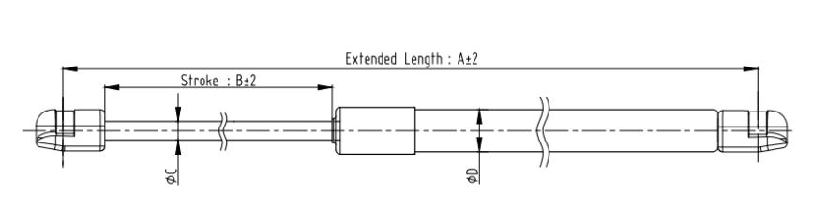
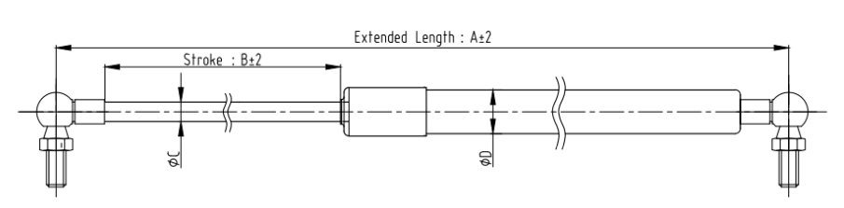

A: mm B: mm C: mm D: mm Force value: N

